Term Project [GameCenter]

CSCI 4370 – Database Management

DataBytes

Brandon Sutton, Landon Murdock, James Schobak

7/29/20

**UML**

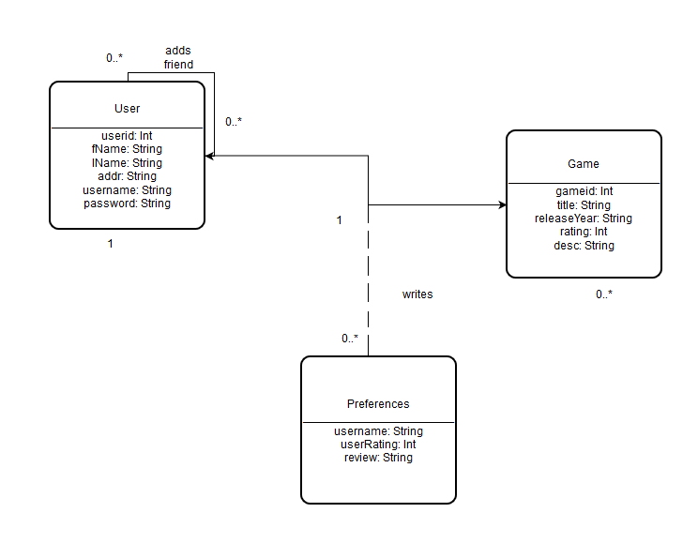

**ER**

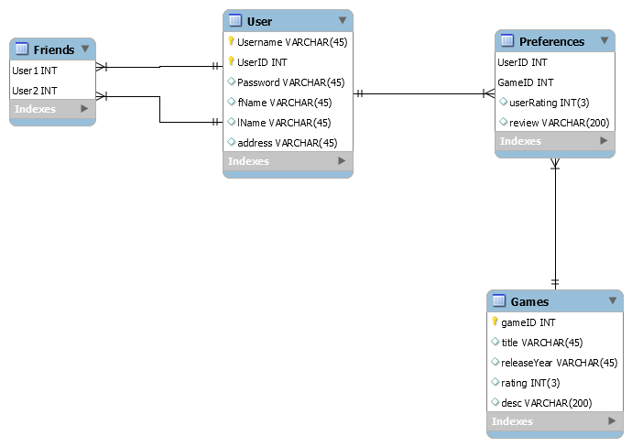

**Relational Mapping**

User(Username, UserID, Password, fName, lName, address)

Friends(User1:FK, User2:FK)

Game(GameID, title, releaseYear, rating, desc)

Preferences(UserID:FK, GameID:FK, userRating, review)

**BCNF**

User:

A = username

B = userId

C = password

D = fName

E = lName

F = address

R = User(A, B, C, D, E, F)

F = B -> A, A -> CDEF

Violation: B -> A

R2 = UserIden(B, A)

F2 = B -> A

Violation: none

R3 = User(A, C, D, E, F)

F3 = A -> CDEF

Violation: none

Friends:

A = User1

B = User2

R = Friends(A, B)

F = none

Violation: none

Game:

A = gameID

B = title

C = releaseYear

D = rating

E = desc

R = Game(A, B, C, D, E)

F = A -> BCDE

Violation: none

Preferencces:

A = userID

B = gameID

C = userRating

D = review

R = Preferences(A, B, C, D)

F = AB -> CD

Violation: none

**3NF**

User:

A = username

B = userId

C = password

D = fName

E = lName

F = address

R = User(A, B, C, D, E, F)

F = B -> A, A -> CDEF

B -> A, A -> C, A -> D, A -> E, A -> F

B -> ACDEF

F’ = B -> ACDEF

R = (B, A, C, D, E, F)

Friends:

A = User1

B = User2

R = Friends(A, B)

F = none

R = (A, B)

Game:

A = gameID

B = title

C = releaseYear

D = rating

E = desc

R = Game(A, B, C, D, E)

F = A -> BCDE

A -> B, A -> C, A->D, A -> E

F’ = A -> BCDE

R = (A, B, C, D, E)

Preferencces:

A = userID

B = gameID

C = userRating

D = review

R = Preferences(A, B, C, D)

F = AB -> CD

AB -> C, AB -> D

F’ = AB -> CD

R = (A, B, C, D)

**Original Contributions**

GameCenter is based off the idea of ratings and reviews. Review sites can be seen everywhere; from movies to restaurants, potential customers often use reviews as a gauge to determine whether they should or should not purchase the product (or service). GameCenter expands on this idea by allowing users to filter reviews and ratings by certain parameters. For example, rather than just viewing a simple “top rated” games list, GameCenter offers a “top rated” list for each sex (male/female).

**Broader Impact**

The modern technology world uses data (such as reviews) for virtually everything. Reviews prove to be extremely useful as users can use them to gauge the quality of the service/product they are interested in. Additionally, business can use the reviews to make their product/service more appealing to their customers. Reviews can sometimes be problematic, however, as customers can heavily differ on their needs, experiences, etc. GameCenter offers a viewing of ratings based on focused parameters (such as sex). By being able to filter ratings by more specific conditions, customers can get a better gauge on whether the product is right for him or her.

**Proposed Architecture**

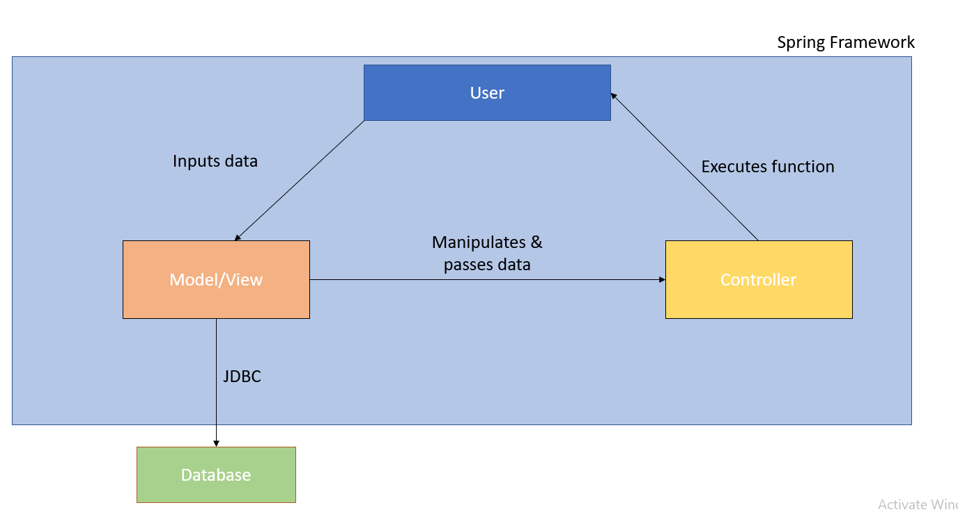

**Team Responsibilities**

Brandon – Most back-end functionality in java

Landon – Diagrams, database design/implementation

James – Front-end design, some database/java

**Conclusion**

In conclusion, we ended up choosing the 3NF for our database design. We believed it to be the most efficient to avoid lossiness. We ended up not needing the userid primary key as username did the trick, however we ended up leaving the key in the design due to time restrictions. Given more time, we would have removed the key and stuck to username as the primary key for the table. We also learned a lot about frameworks and architecture design. We ended up mixing the model and view together in the MVC architecture. It was interesting to work in this kind of architecture; however, we agreed that we should have stuck to a more traditional MVC design.